LEP – Sub Committee

LEP - Lancashire Skills and Employment Advisory Panel

Private and Confidential: NO

Date: Wednesday, 3 March 2021

Fast Track Digital Workforce Fund and DfE Digital Skills Bootcamps

Report Author: Kerry Harrison, Lancashire Digital Skills Partnership Coordinator, Kerry.harrison@lancashirelep.co.uk

Executive Summary

This paper provides an overview of the Fast Track Digital Workforce Fund, delivered in partnership with the Department for Digital, Culture, Media and Sport (DCMS) and the Greater Manchester Combined Authority (GMCA) and progress to-date, and how this has fed into the trialling of Digital Skills Bootcamps with DfE, and the subsequent national roll out under the National Skills Fund.

Recommendation

The committee are asked to note the update, and to reflect on the Bootcamp approach, alongside the employer insight from Nicola Mortimer. Committee members are asked to reflect on the model and how this can be integrated into provider models locally, as well as inform the potential for Local Skills Improvement Plans, as referenced in the Skills for Jobs White Paper.

- Background

  - The Fast Track Digital Workforce Fund, which was developed to address locally identified digital skills gaps, is a joint venture between the Department for Digital, Culture, Media and Sport (DCMS), Greater Manchester Combined Authority (GMCA) and Lancashire Digital Skills Partnership (LDSP).

  - The £3 million fund, which was the first of its kind in the UK, was set up to support both Greater Manchester and Lancashire residents with accessible routes into digital employment. The approach was very much devolved, with funds awarded via a Section 31 grant, with market engagement and commissioning of provision run locally, with GMCA as the accountable body.

  - The Fast Track programme was a 'test and learn', to investigate the success of intensive training programmes in addressing skills shortage areas, whilst also supporting disadvantaged and under-represented groups into high value digital roles.

  - Consortia of employers and training providers have come together to co-design and co-deliver innovative, short, intensive training packages aimed at filling specific roles in priority skill areas, with participants who complete the packages receiving guaranteed interviews. Programmes are typically between 10-20 weeks in length, dependent on the delivery style, for example, whether part-time or blended.

  - This approach has enabled local innovation to meet skills priorities including more niche skills requirements such as Electech, where the funding has supported a cluster of electronics firms in Lancaster with multiple vacancies. An insight into this programme will be provided at the meeting by Nicola Mortimer.

  - In Lancashire, we initially benefited from eight projects including:

    - Additive Manufacturing – The Growth Company/Made Smarter working with Manchester Metropolitan University running an additive manufacturing programme aimed at upskilling employees in local manufacturers.
    - Cyber Ready NW – CompTIA lead this programme, which is focused on junior cybersecurity roles.
    - DEEPer – Digital Engineering Education Programme run by E4All and Community Business Partners – training PHP developers.
    - DevOps Skills by the Open University with DXC in Chorley.
    - IN4.0 Talent Academy – Data Science, Cyber-Security and cloud-based computing applied to manufacturing sector run by the IN4.0 Group. This programme has seen 24 participants enter full time employment so far.
    - Power Up – A digital marketing focused programme run by West Lancashire College and The Extraordinary Club.
    - Project Uplift – A digital engineering and robotics programme run by Burnley College.
    - Tech Lancaster – Electronics focused training for roles such as Design Engineer, Embedded Software Engineer, Project Engineer, and Technicians. This is run by a consortium of Electronics companies in Lancaster.

  - The Fast Track Fund is currently supporting 620 Lancashire and Greater Manchester residents. The majority of the Lancashire programmes are still in the delivery phase, with numbers into employment to be reported once the delivery phase has completed.

2. Digital Skills Bootcamps Trailblazer

- DCMS, GMCA and the LDSP shared the Fast Track Fund model with the Department for Education (DfE), with view to influencing skills policy, and for DfE to learn from and potentially adopt the model. In the summer of 2020, the DfE launched the Digital Skills Bootcamps trailblazer, with view to piloting the approach to inform the development of the National Skills Fund and associated policy. GMCA and the LDPS were invited to expand the Fast Track programme as part of the trailblazer.

- The Prime Minister announced the Phase 1 trailblazer in a speech in September 2020. It included activity in Lancashire and GMCA, and West Midlands Combined Authority, with both areas having piloted this style of provision with DCMS and DfE respectively, and Liverpool City Region. These partners received funding through a Section 14 Grant (with GMCA the accountable body for Manchester and Lancashire, working in partnership with the LDSP), building on the devolved approach adopted by DCMS.

- This was expanded in the autumn to include the Heart of the South West Digital Skills Partnership (DSP) and Devon County Council, D2N2 LEP and West Yorkshire Combined Authority DSP. These partners were invited to tender as part of an ITT process run by DfE contracting team.

- Through the DfE Digital Skills Bootcamp programme, an additional 303 residents in Lancashire and GMCA have been recruited to programmes so far, with one programme currently in the process of recruiting.

- Lancashire residents have benefited from a further eight projects including programmes for Digital Marketing, DevOps, Cloud Engineering, Cyber Security Technologists, Data Engineering and Digital Customer Services. A summary can be seen in the diagram.

- The projects proved popular with all courses being oversubscribed. For example, IN4.0 has 480 applicants for 70 places, Blackburn Rovers had 143 applicants for 60 places, QA had 300 applicants for 35 places and Tech Returners had 170 applicants for 40 places. Please note, except for the Blackburn Rovers programme, all applicants are a mix of Lancashire and GMCA residents.

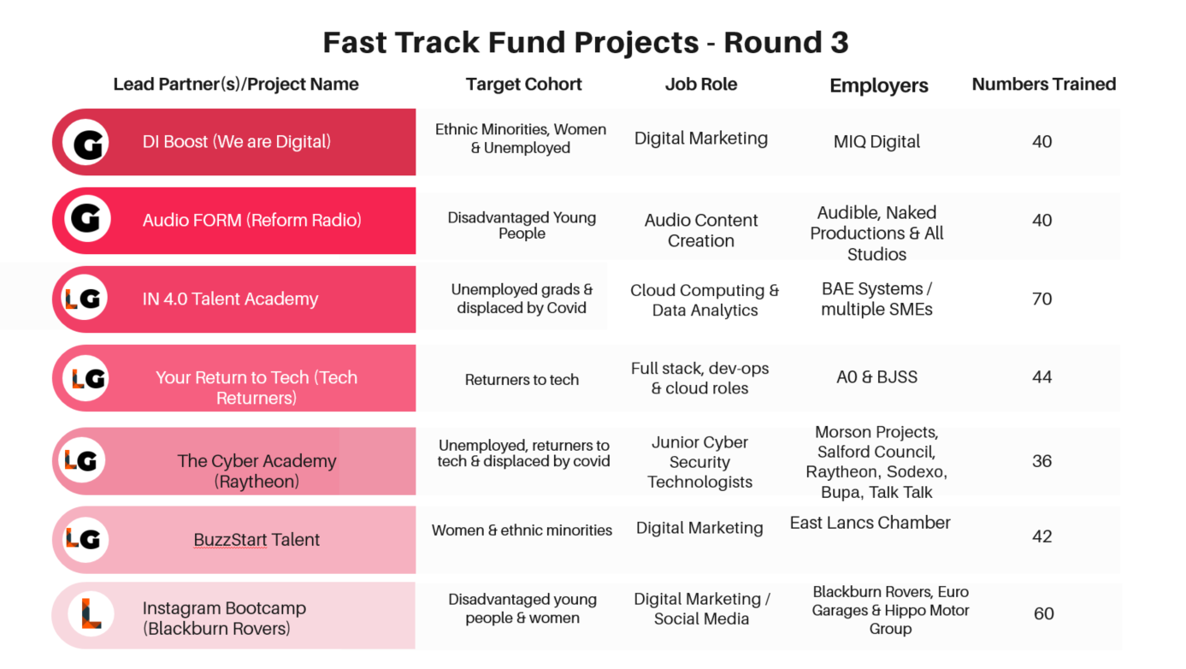

3. DfE Digital Skills Bootcamps Invitation to Tender (ITT)

- The DfE are now rolling out the pilots of Skills Bootcamps across England under the National Skills Fund, to test whether they could be used to upskill people in other technical areas, as well as digital. A national procurement process was initiated with a market engagement event just prior to Christmas, with the Invitation to Tender (ITT) launching in January 2021. The deadline for submissions was the 12th February. The approach moves away from a locally devolved model, as per the Fast Track Fund and the initial trailblazer.

- There are two lots totalling £36 million:

- Lot 1 is specifically for Digital Skills Bootcamps and will be split across the nine regions of England. There will be a minimum of one contract per region and those contracts do not have to cover the whole region.
- Lot 2 covers digital skills in multiple regions or other technical skills in one region or multiple regions.

- There is an expectation that bidders will link their offer to the local needs of an area, by referencing local priorities and relationships with local employers – as Bootcamps should lead to guaranteed interviews and ultimately employment.

- However, LEPs and MCAs and associated Skills Advisory Panels have not been invited to contribute to the tender documents to ensure the ITT reflects local needs and have not been invited to support the assessment of the strategic fit of the bids. Instead, LEPs and Mayoral Combined Authorities (MCAs) have been invited to bid as part of the process alongside providers. Ideally, either the funds would be devolved, as previously, or the LEPs/MCAs would be strategic partners in procuring activity to ensure strategic fit of activity, rather than bidding via a national procurement process and potentially bidding in competition with provider-employer consortiums. These concerns have been raised with the DfE by the LDSP, GMCA and other LEP and MCA areas.

- The DfE have been asked to compare the impact of programmes under the devolved approach with the nationally procured approach as part of the evaluation of the Skills Bootcamps. An extension to the current Section 14 grant has been agreed to continue some activity under the roll out in Lancashire and GMCA, alongside any activity secured via consortiums through the national process.

- It should also be noted that the DfE ITT is more generic in relation to target groups, whilst the Fast Track Fund was targeted at under-represented groups, with the following specific aim: "Diversify the digital talent pipeline by targeting groups that are currently under-represented in digital roles and designing training programmes to meet their specific needs." The DfE are keen to engage a wider range of groups to evaluate the impact of the programme on how it removes barriers to people pursuing digital and technical careers.

- In addition to the conversations with DfE, the LDSP and GMCA have also facilitated meetings with LEPs and MCAs areas across the North West to ensure there was transparency between the areas in regard to responding to the ITT and in cross sub-regional bids.

- Lancashire's approach to the ITT

- As lot 1 was regionally based, to minimise regional competition and maximise chance for opportunity, GMCA and Lancashire agreed to continue to work collaboratively.

- It was decided that as strategic bodies that the LDSP/LEP and GMCA would not submit bids but would endorse and support consortia bids in the area; facilitating relationships between providers to build strong consortia.

- There are a number of lot 1 and lot 2 bids being submitted that will build on the journey to-date and enable access to Skills Bootcamps in Lancashire, subject to the DfE procurement process.

5. Recommendation

5.1 The committee are asked to note the update, and to reflect on the emerging approach, alongside the employer insight from Nicola. Committee members are asked to reflect on the model and how this can be integrated into provider models locally, as well as inform the potential for Local Skills Improvement Plans, as referenced in the Skills for Jobs White Paper.

List of Background Papers

Paper | Date | Contact/Tel
N/A

Reason for inclusion in Part II, if appropriate

N/A

